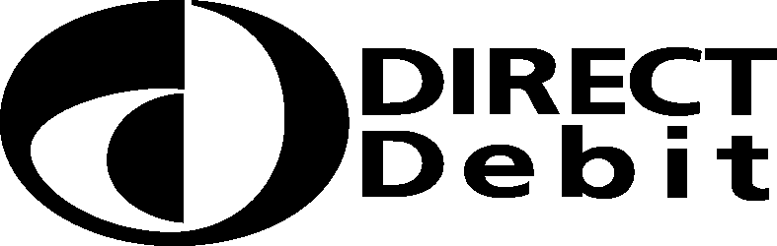

C I Y M S

Please fill in the whole form including official use box using a ball

Instruction to your

bank or building society to pay by Direct Debit

point pen and send it to: Service user number
C I Y M S
ATTN: MR R BARNES 91 CIRCULAR ROAD BELFAST
BT4 2GD
2
1
1
2
5
2
Name(s) of account holder(s)

Bank/building society account number

Branch sort code Instruction to your bank or building society
Please pay C I Y M S Direct Debits from the account detailed in this Instruction subject to the safeguards assured by the Direct Debit Guarantee. I understand that this Instruction may remain with C I Y M S

Name and full postal address of your bank or building society
FOR C I Y M S OFFICIAL USE ONLY
This is not part of the instruction to your bank or building society.
To: The Manager
Bank/building society
Postcode
Address

and, if so, details will be passed electronically to my bank/building society.

Date
Signature(s)
Reference (office use only)

Banks and building societies may not accept Direct Debit Instructions for some types of account

DDI1

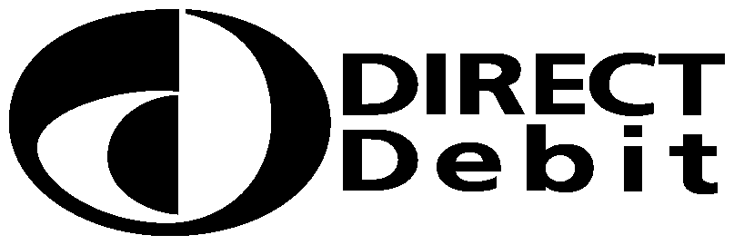

- This Guarantee is offered by all banks and building societies that accept instructions to pay Direct Debits
- If there are any changes to the amount, date or frequency of your Direct Debit (C I Y M S) will notify you (10) working days in advance of your account being debited or as otherwise agreed. If you request (C I Y M S) to collect a payment, confirmation of the amount and date will be given to you at the time of the request.
- If an error is made in the payment of your Direct Debit, by (C I Y M S) or your bank or building society you are entitled to a full and immediate refund of the amount paid from your bank or building society
– If you receive a refund you are not entitled to, you must pay it back when (C I Y M S) asks you to
- You can cancel a Direct Debit at any time by simply contacting your bank or building society. Written confirmation may be required. Please also notify us.

